FUTURE BME 2026

Vrdnik, Serbia, 29.9. – 30.9.2026.
Please return the completed form to the reception of the Movenpick Resort & Spa Fruške Terme hotel

The reservation is accepted only in this form

Date:

Name:

City:

Country:

E-mail:

Arrival date:

Departure date:

HotelMovenpickResort&SpaFruškeTerme4*29.9. – 30.9.2026.

Bed and breakfast – 125,00 EUR in single room per person per night;69,50EURin double/twin room per person per night

City tax:110,00RSDper person per night
*The price in RSD depends on the middle exchange rate of the NBS on the date of invoice issuance

The package includes:
*Checkin at 2:00 PM, check out at 11:00 AM
*Accommodation based on the selected service
*Water world
*Saunaworld
*Non-alcoholic minibar+coffee machine in the room
*Parkingin the garage

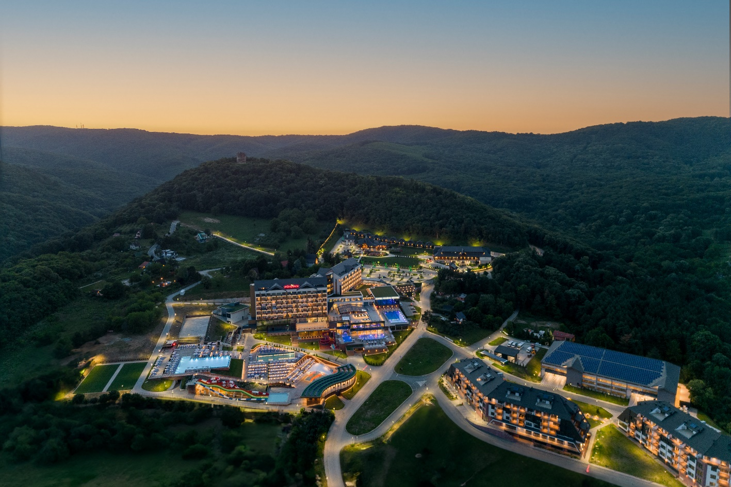

Accommodation type according to availability:
Please mark the accommodation type
1.Singleroom (accommodation for one person)
2.Double / twinroom (accommodation for two people)

A 100% advance payment is required to confirm the reservation.
If you wish to make the payment through the company account, it is necessary to provide the company's ID details.

Accommodation reservations can be made no later than 23.09.2026., subject to availability.
For reservations made after this date, the hotel does not guarantee the price or availability.

Cancelation policy:
50% of the paid ammount is retained by the hotel if cancellation occurs 14 days before arrival.
100% of the paid ammount is retained by the hotel if cancellation occurs 7 days before arrival.

We wish you a pleasant stay!

Addressfor reservations: info@frusketerme.com

Phone:
+381 (0)22/21-55-260
+381 (0)63/495-477

