TITLE OF THE PAPER IN UPPERCASE
(Cambria Bold, 14pt, Align Left)
First Author ^{[0000-1111-2222-3333]}, Second Author² ^{[1111-2222-3333-4444]}

Abstract
The abstract should summarize the paper's contents in brief, approximately 250 words. This paper explores the consequences of working abroad in the country of emigration by comparing the sociodemographic characteristics of two waves of emigrants: those who migrated in the second half of the 20th century and those who left at the beginning of the 21st century. The analysis encompasses two spheres – the private and social realms, considering both positive and negative aspects.
Key words: workers abroad, country of origin, country of reception, positive consequences, negative consequences.

1. Introduction

The paper should range between 5 and 8 pages and must be submitted in English. Text: Cambria 10pt, single spaced, justified. Titles (Cambria, 12pt, Bold, space before 10pt, and space after 10pt) and subsections (Cambria, Bold, 10pt, space before 10pt, and space after 10pt) within the text should be numbered. Authors are advised to adhere to the guidelines of the American Psychological Association (APA) Style 7th edition for proper referencing and citation in their submissions.
Paper size is B5 (165 x 235 mm). Margins are: TOP = 2.5 cm BOTTOM = 2 cm, INSIDE/OUTSIDE = 2 cm.

1.1 Section (methods)

Figures/drawings must be integrated into text. Number all figures and tables and refer to them in the text as Figure 1 or Table 1. Titles in Cambria 9pt, Italic should be placed bellow Figures (Centred) and above Tables (align left). Text in Tables should be in Cambria, 9pt.
In-text references (Smith & Bruce, 2018). Quotes: (Smith & Bruce, 2018, pp. 25-26). Narrative citations: If an in-text citation has the authors' names as part of the sentence (that is, outside of brackets) place the year and page numbers in brackets immediately after the name, and use 'and' between the authors' names: Jones and Smith (2020, p. 29)

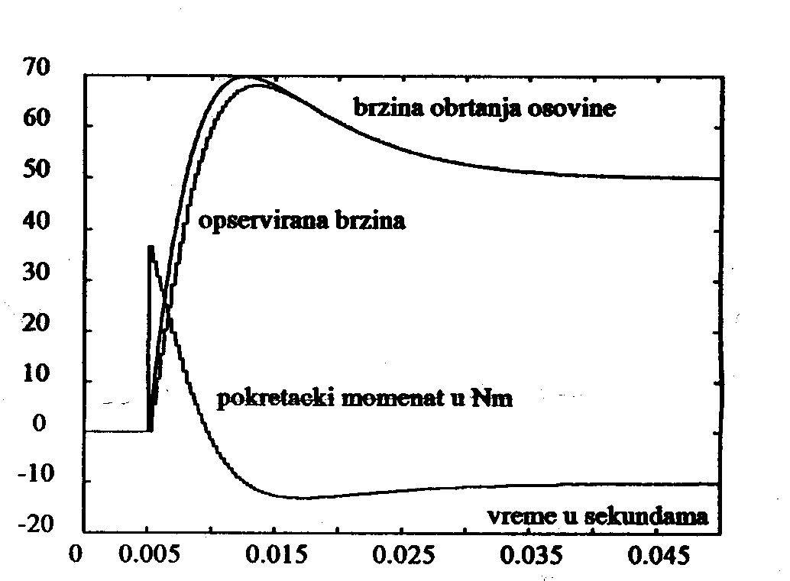
Figure 1: Simulation results

Table 1: Parameters and speed
 | Parameter 1 | Parameter 2 | Parameter 3
Speed 1 | 23 | 75 | 90
Speed 2 | 12 | 55 | 67

2. Section (results)

Ut wisi enim ad minim veniam, quis nostrud exerci tation ullamcorper suscipit lobortis nisl ut aliquip ex ea commodo consequat. Duis autem vel eum iriure dolor in hendrerit in vulputate velit esse molestie consequat, vel illum dolore eu feugiat nulla facilisis at vero eros et accumsan et iusto odio dignissim qui blandit praesent luptatum zzril delenit augue duis dolore te feugait nulla facilisi.

2.1 Subsection

Ut wisi enim ad minim veniam, quis nostrud exerci tation ullamcorper suscipit lobortis nisl ut aliquip ex ea commodo consequat. Duis autem vel eum iriure dolor in hendrerit in vulputate velit esse molestie consequat, vel illum dolore eu feugiat nulla facilisis at vero eros et accumsan et iusto odio dignissim qui blandit praesent luptatum zzril delenit augue duis dolore te feugait nulla facilisi.

3. Section (discussion)

Nam liber tempor cum soluta nobis eleifend option congue nihil imperdiet doming id quod mazim placerat facer possim assum. Ut wisi enim ad minim veniam, quis nostrud exerci tation ullamcorper suscipit lobortis nisl ut aliquip ex ea commodo consequat. Duis autem vel eum iriure dolor in hendrerit in vulputate velit esse molestie consequat, vel illum dolore eu feugiat nulla facilisis.

4. Section (conclusions)

At vero eos et accusam et justo duo dolores et ea rebum. Stet clita kasd gubergren, no sea takimata sanctus est Lorem ipsum dolor sit amet. Lorem ipsum dolor sit amet, consetetur sadipscing elitr, sed diam nonumy eirmod tempor invidunt ut labore et dolore magna aliquyam erat, sed diam voluptua. At vero eos et accusam et justo duo dolores et ea rebum. Stet clita kasd gubergren, no sea takimata sanctus est Lorem ipsum dolor sit amet. Lorem ipsum dolor sit amet, consetetur sadipscing elitr, sed diam nonumy eirmod tempor invidunt ut labore et dolore magna aliquyam erat.

Acknowledgments

Use the singular heading even if you have many acknowledgments.

REFERENCES (Alphabetically ordered, Align Left, APA style)

- Author, A. A., & Author, B. (2019). Article title. Journal, 8(3), 207–217. https://doi.org/xx.xxx/xxxx
- Author, A., & Author, B. (2017). Article title. In A. Editor & B. Editor (Eds.), Book title (pp. 25–37). Publisher. http://www.website.com
- Author, A., & Author, B. (2017). Book Title (2nd ed.). Publisher. https://doi.org/xx.xxx/xxxx
- Author, A. (2015). Chapter title. In A. A. Editor (Ed.), Book title (4th ed., pp. 50–95). Publisher.
- Author, A. A. (Ed.). (2015). Book title (3rd ed.). Publisher.
- Author, A. A. (Date). Title of paper. In A. Editor & B. Editor (Eds.), Title of proceedings (212–224). Publisher. DOI OR URL if relevant.
- Author, A. A. (2020). Title of thesis: Subtitle [Type of thesis, name of institution awarding degree]. Name of archive or site. http://www.website.com
- Author, A. (2009, August 12). Title. Name of Website. http://www.website.com

For additional examples, please explore the APA style 7th edition online.

University, e-mail ² University, e-mail

